**Mallu Sravana Sandhya Assessment-9 13/12/2023**

IF else : this are used to execute the statements only when the specified condition is true

Syntax:

If condition:

#statements

Else:

#statements

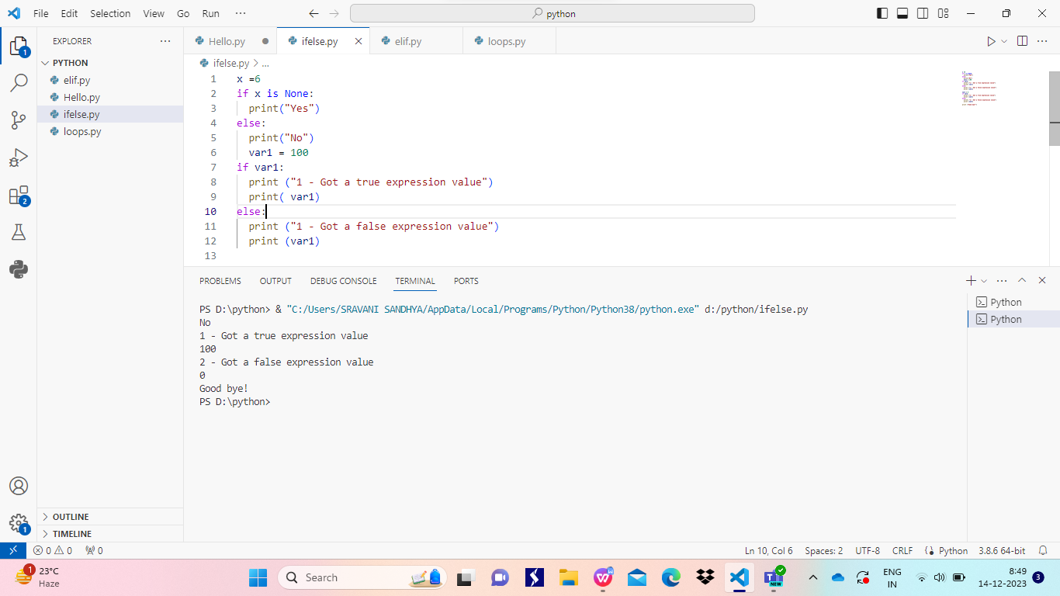

ELIF:

This is similar to switch in C language which meets many number of conditions in elif if the condition is true it executes that block of statements otherwise it checks other condition and so on if no condition is true then it executes else block

Syntax:

If condition:

#statements

Elif condition2:

#statements

Elif condition3:

#statements

…

Else:

#statements

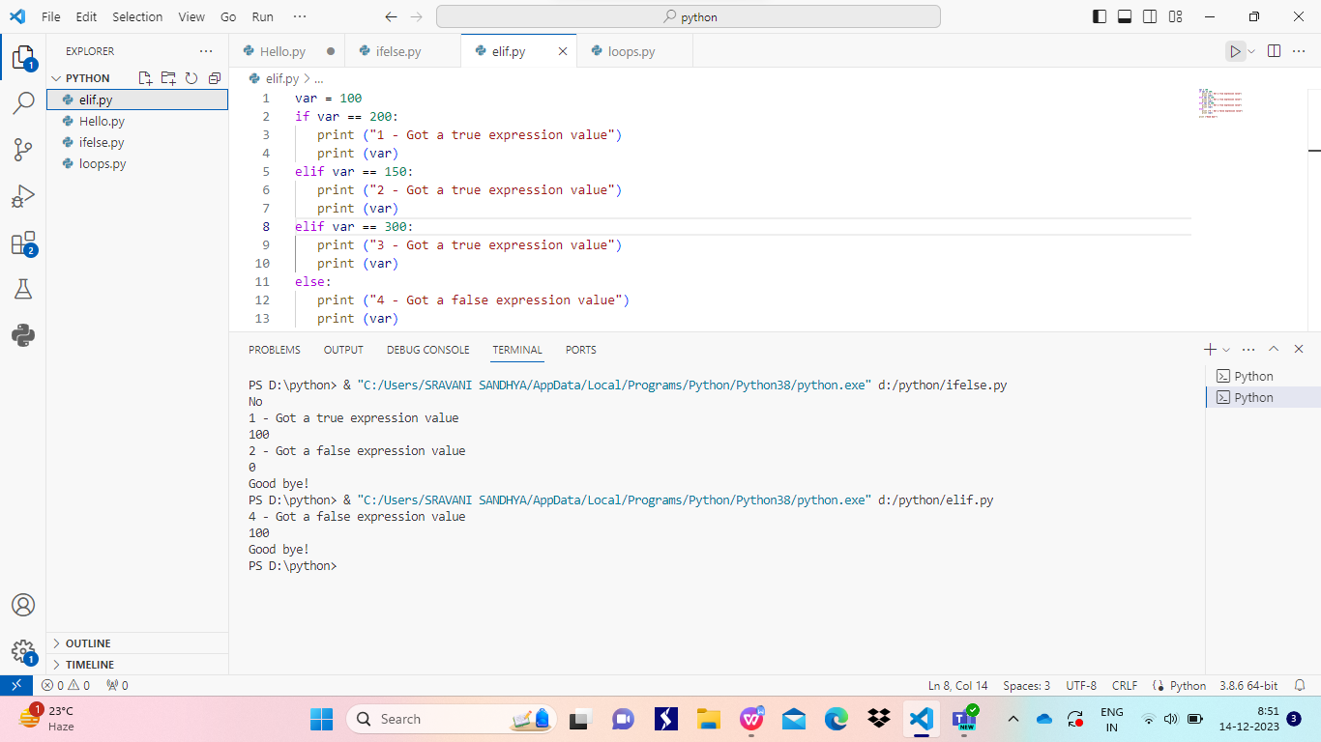

Loops :These are used to iterate a block of statements for any number of times

For loop: it iterates for specified number of times mentioned in the range function

Syntax: for iterator in range(start,stop,step):

#statements

While loop: it iterates the block of statement until and unless the condition in while is true

Syntax: while condition:

#statements

We can also use else for while loop which executes when the condition in while is false

